1. Now we have client id and client secrete after registering out client app with Github Authorization Server.
2. Let’s see what are the changes we need to make to Spring App when Spring Security app wants to leverage Oauth framework during login?
3. **Add the following dependency:  
   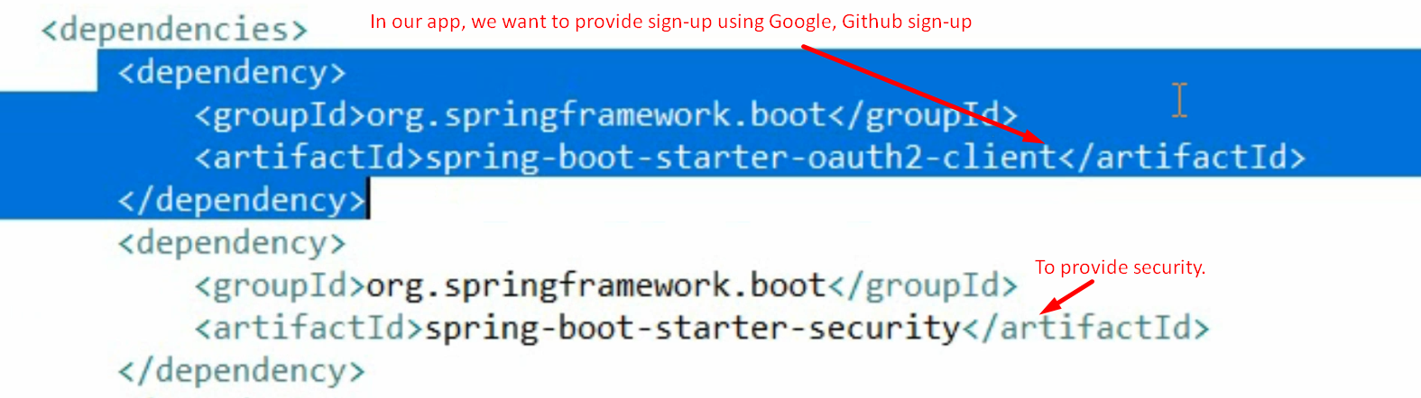**
   1. Because we’re going to consume the auth server which is built outside my app.
   2. If you want to build your own Authorization Server then you can include dependency related to oauth2 server.
4. Main Class:  
   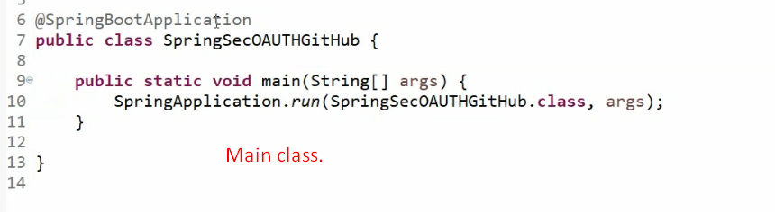
5. 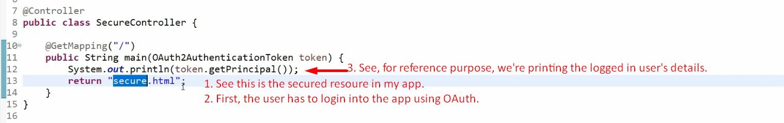
6. 
7. 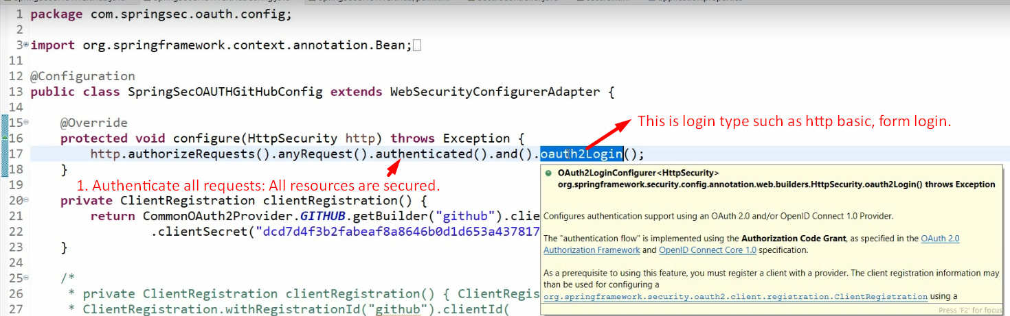
   1. As soon as we add the oauth login type, a filter is added in filter chain. Let’s see in next slide.   
      
8. We know in OAuth, following different components are involved.
   1. A User (Resource Owner).
   2. Authorization Server.
   3. Resource Server.
   4. A Client (Accessing a user’s resource on his behalf from a different server)
9. In this scenario, our app itself is resource server as well as client.
10. When a user tries to access resource on this app, the user is asked to prove his identity by providing his Github credentials on the redirected Github URL.
11. Now some configurations related to Oauth in our app.   
    (Technically, we have to register the client in our app)
    1. **Client Details**: As we’re using Oauth so we need to configure client id and client secrete (password) for the Github which we received during our app registration on Github.
    2. Second, we need to configure the auth server we’re using for Oauth.
12. **Client Details**: There are 3 different ways to configure client details.
    1. **1st**: This is long approach and useful if you implement your own auth server (not using famous ones 🡺 Google, Github, facebook).  
       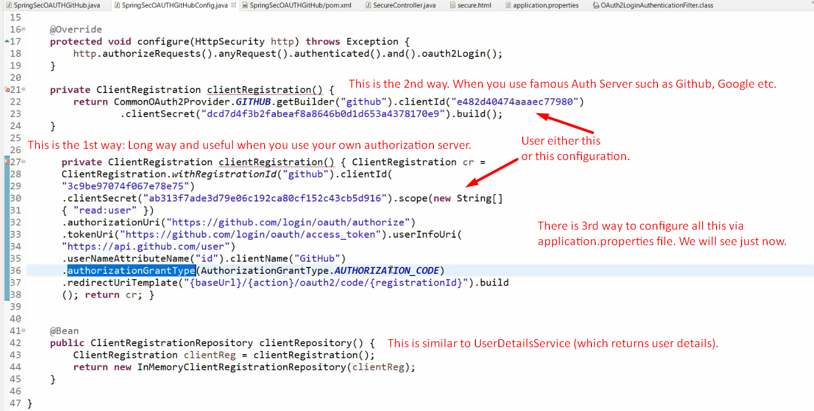  
       NOTE: In line# 21, using the following to make our life easy when defining oauth configuration for famous auth servers.  
       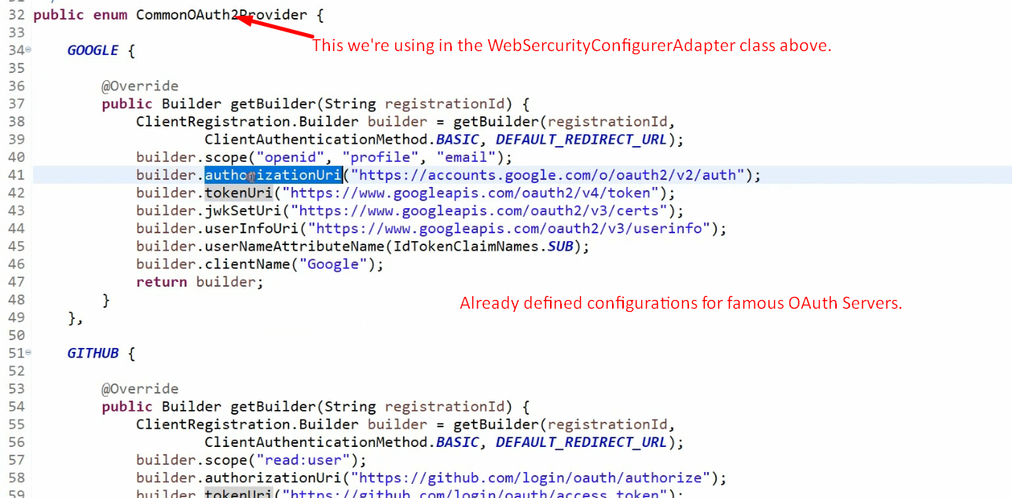
       1. **ClientRegistration** Class: To configure client details. Builder Class.
          1. **ClientRegistration.withRegistrationId(“Github”):** Which company/organization/auth server, we’re using.
          2. **AuthorizationGrantType.java**  
             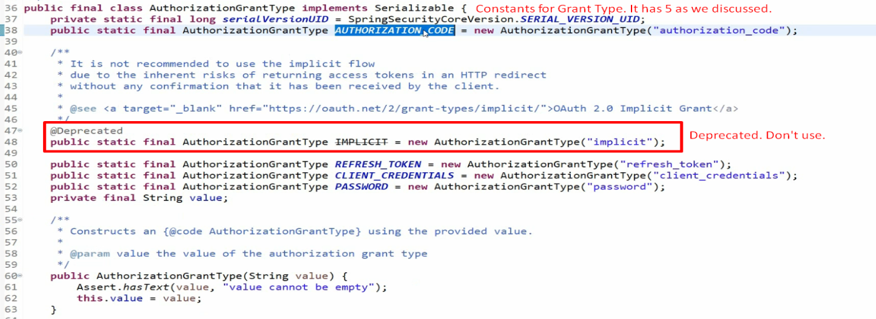
    2. 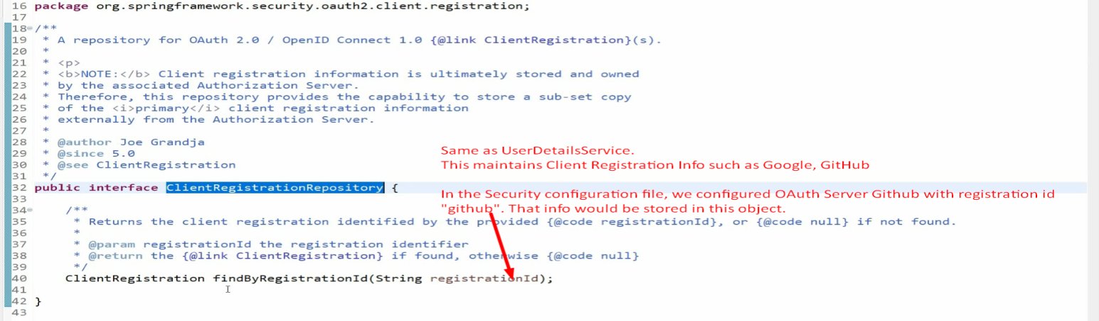
    3. 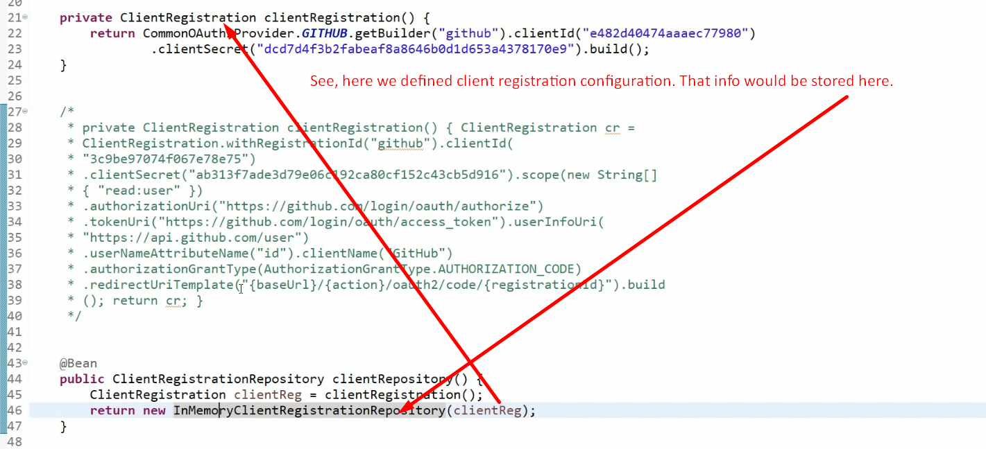
    4. 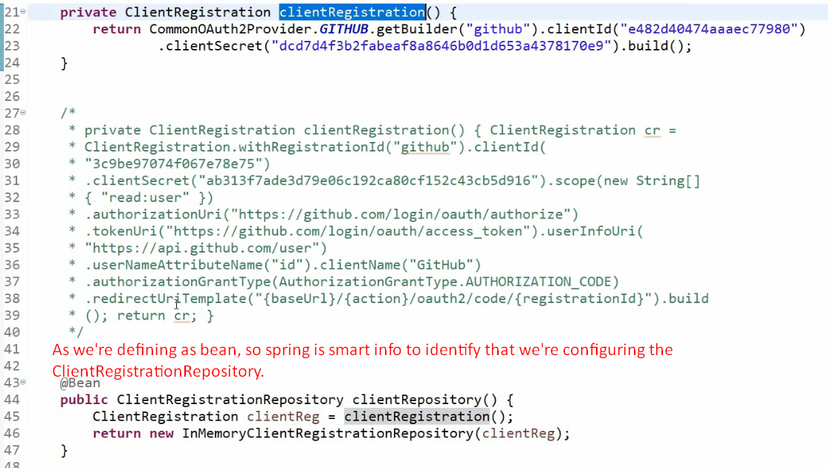
    5. 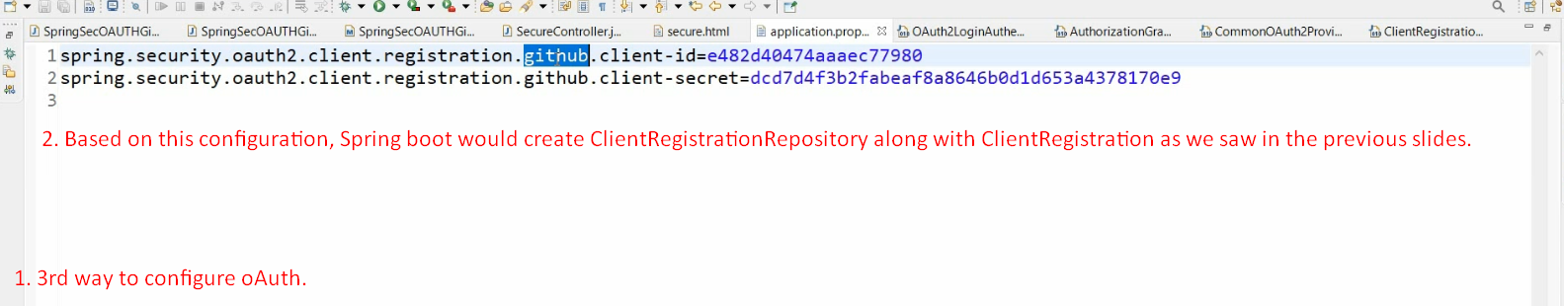
    6. 